MUSHROOM CLASSIFICATION

Wireframe Documentation

**Home/Prediction page**

1.The first thing you see after enter the page is stick below

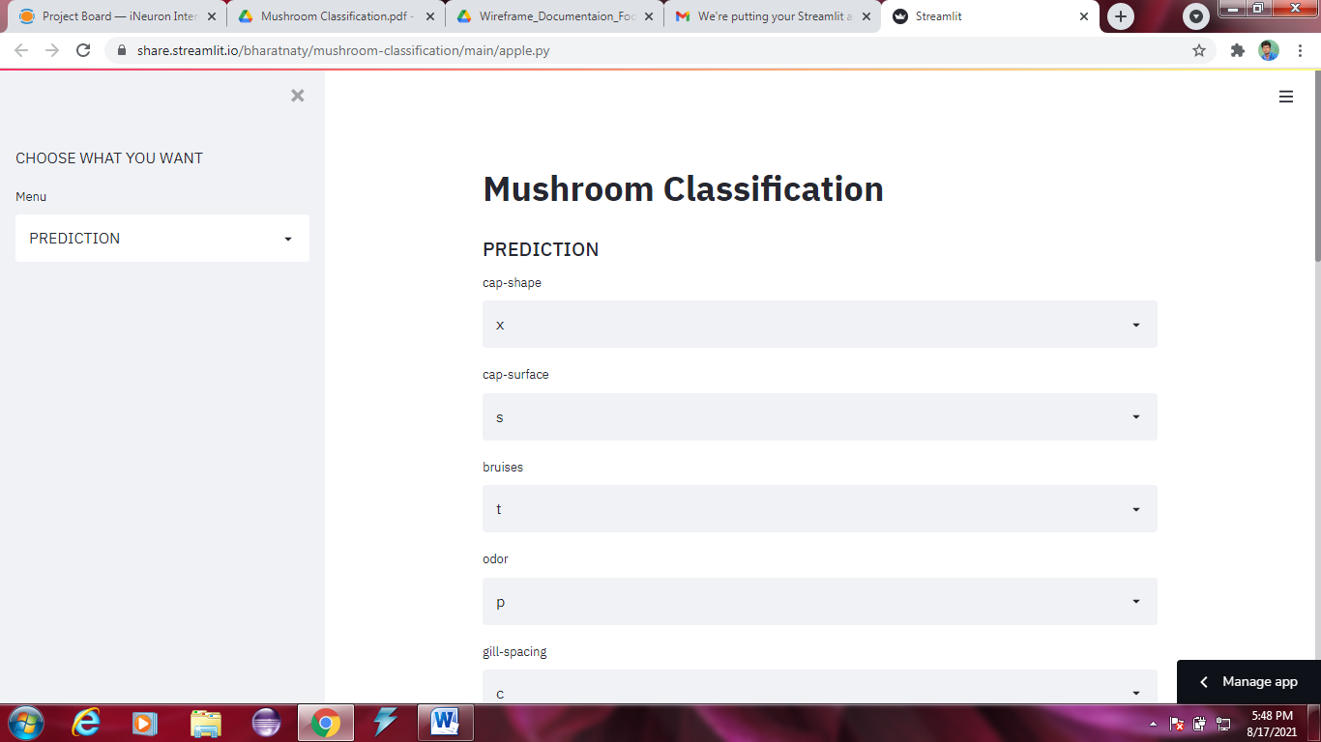

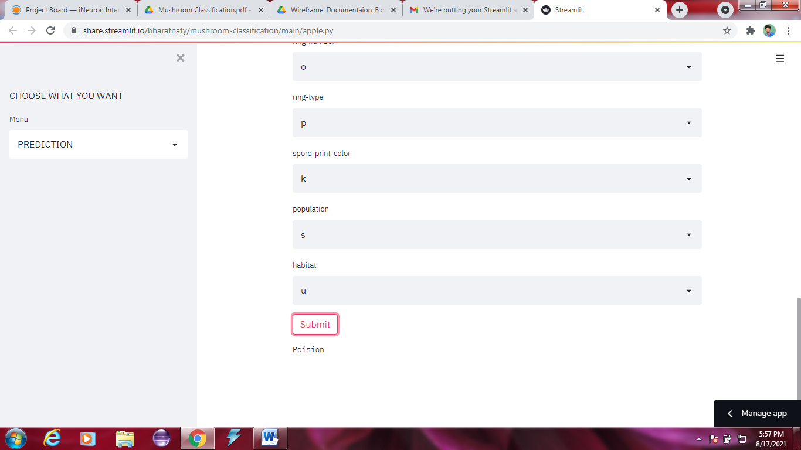

2.user can be change the page to us and read about tiny description

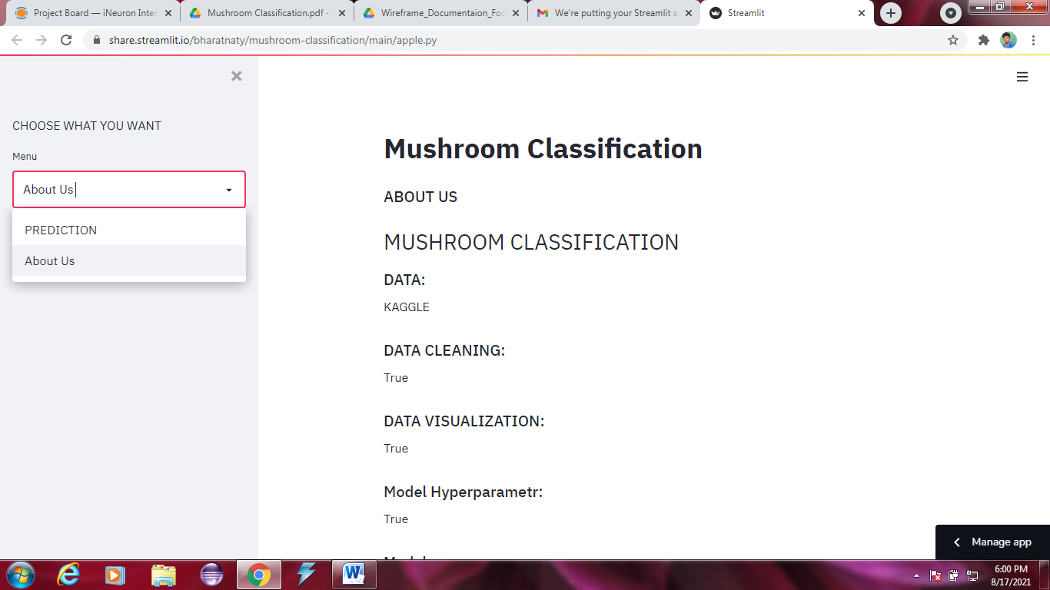

PREDICTION PAGE

Get input

Get input

Get input

Get input

submit

*we get the input from user

*after submiting data we will get output